CIS 4318
Fall, 2020
Final

Exam Requirements
- The exam time is from 2:00 pm to 4:30 pm at Dec. 7.
- It is an open-book & open-note exam.
- You use NetBeans 8.2 to develop a Web Application (project).
- Your submission is a zip file that includes all your project files.
- You submit the zip file to CANVAS.
- You must follow the university honor code (see https://www.txstate.edu/honorcodecouncil/).
- You can use Zoom to ask questions during the exam time.
You must NOT use the default package to create your Java class. Moreover, you must name your package using your Texas State net ID (such as edu.txstate.bc99, where bc99 is a student’s Texas State net ID). Failing to follow this requirement may cause a 20-point deduction of your grade.

Lab: You are required to develop a crowdfunding application to raise money for an individual or organization by collecting donations via the web. You must use the MVC pattern to develop this web application. Moreover, the application uses a database (cis4318_students) available in the server: sql.mccoy.txstate.edu.

Algorithm
- An opening JSP page (welcome.jsp) displays a welcome message. This page includes a link to send a request to a servlet to open the second page.
- The second JSP page shows a list of fundraisers available to a user. Note that the fundraisers’ data are available in the database.
  - This page displays the id (int), title, organizer, and goal amount (double) of each fundraiser.
  - This page provides a Select button (link) for each fundraiser. The user clicks the button to select the fundraiser.
- The third JSP page displays the selected fundraiser. If the user has donated in the past, this page also displays the fundraiser’s title of the user’s last donation. Note that only one fundraiser can be selected. It also provides two buttons: BACK and DONATE.
  - The BACK button is clicked to go to the second page. The user can replace the selected fundraiser.
  - The user clicks the DONATE button to donate. This page also provides three input fields: donor name, email, and amount for the donation.
  - After the DONATE button is clicked, the donation data must be saved in the database. Then the fourth page is returned with a thank you message.
- You must use the MVC pattern to develop this web application. Your app must have two bean classes. The Fundraiser bean that includes the id, title, organizer, and goal amount. The Donation bean used to store its donor name, email, amount, and fundraiser id.
- Database: The database includes two tables: Fundraiser and Donation_X, where X means your Net ID. For example, a student’s Net ID is bb99. Then, the name of the donation table used by the student’s exam project should be Donation_bb99. Failure to follow this requirement to use the correct table may result in a 30-point deduction of your grade. You can see the figure below for an example showing the tables’ columns and a relation between the tables. Note that, in your donation table (Donation_X), the id is generated automatically when a record is inserted into the table. In other words, the insert statement used in JDBC does not need to provide an id value. One fundraiser can have many donation records.
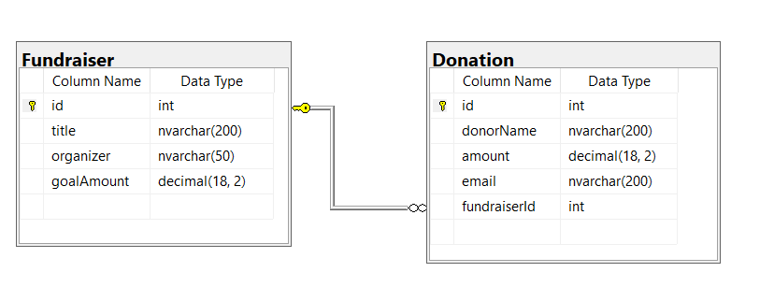

You must turn in your project as a zip file and turn it in using the Assignments (FINAL) on the CANVAS.

